Week 8 summary

By Angelo Anthony Rettob  
IGAD Programmer, 181494

Table of contents

**Monday** **3**

8:00-9:30 Update monster walk conditions 3

9:30-11:30 Add user shoot command 3

11:30-12:30 Make all entities able to shoot 3

12:30-13:30 Make level transition possible 3

13:30-15:00 Helping peers with linker errors 4

15:15-16:15 making doors able to disappear 4

16:30-18:00 Implement side screen display. 5

**Tuesday** **6**

**Wednesday** **7**

11:00-13:00 Getting inventory to be written on the screen 7

18:30-20:45 Update AABB collision response and hitboxes 8

20:45-22:00 Stopping the player from being pushed around by monsters 10

**Thursday** **12**

7:15-8:30 9:30-10:00 Work on reflection 12

11:30-12:00 Asking learning log feedback 12

12:30-14:15 Finish the PDP 12

14:30-16:00 Implement pop up system 12

**Friday** **13**

10:00-11:00 Fix bug where the game would crash if the player died 13

11:00-11:45 Write week 6 and 7 ILOs 13

11:45-12:00 Add breakable walls and added food 13

12:15-12:30 Spawners can be broken and the game restarts at the end 13

# Monday

### 8:00-9:30 Update monster walk conditions

Monsters can walk diagonally through tiles, I may be able to fix that by only checking the surrounding tiles. If there are any monsters or objects there, it is impossible to overwrite that position.

### 9:30-11:30 Add user shoot command

We first have to implement the new projectile design.

Fixed monster animation.

While implementing the projectile design there actually were some oversights. There was no way to upgrade stats of the projectile launcher, so the entity class needs shoot getters, even though some entities can’t shoot.

### 11:30-12:30 Make all entities able to shoot



Entities use the same class as the player. The projectile launcher class. It only has to define a direction and it can shoot.

### 12:30-13:30 Make level transition possible

I first have to make sure that the player isn’t deleted when a new level is loaded.

An exit tile has access to the Map. We can easily load a new level by requesting a new map. We just increase the level. Every level is formatted with its level name. Both numbers reflect each other.



### 13:30-15:00 Helping peers with linker errors

There was this weird bug where David his header file was being seen as a source file. Changing this in the properties solved the problem.

Bas included many files which probably resulted in circular dependency. But somehow it got fixed. We are not sure why. At one moment the problem just disappeared and we couldn’t reconstruct it anymore.

### 15:15-16:15 making doors able to disappear

This was quite hard to do. To make doors able to disappear, I need some way to access the player's inventory, but that would require static casting and we should depend upon interfaces and not implementations.

Because of that, the way I’m gonna do it is by adding a virtual function called setDead. This way, when a gate is supposed to die, the player decides if it is supposed to die. The player doesn’t need any casting and the door doesn’t need to know about the inventory.



The textures are not correct but the gates can now be removed.

### 16:30-18:00 Implement side screen display.

To implement the sidebar, we need to draw a coloured rectangle, but the thing that is harder is that I have to limit what is displayed by the game. The reason why this is a hard thing, is because the player is selected as center position.

I will probably use an offset in my map class, but I still need a way to draw the inventory

# Tuesday

Spend most of my time playing games with little brother

# Wednesday

### 11:00-13:00 Getting inventory to be written on the screen



### 18:30-20:45 Update AABB collision response and hitboxes

### 

The reason why this happened was that collisions were checked in this order.

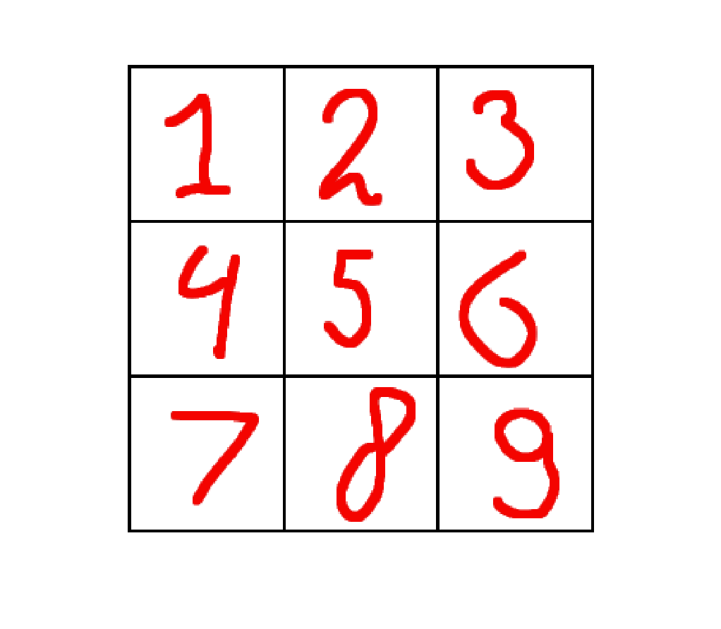

Consider the following situation.

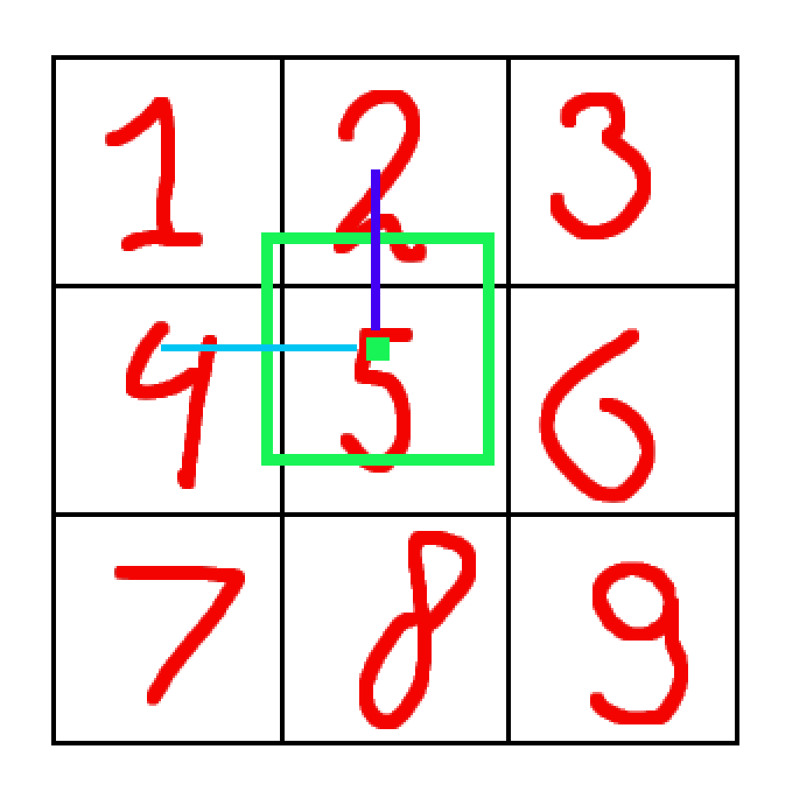

The way that I calculate the direction in which the objects should snap is by moving it from the largest vector. The collision gets solved as it should, but the problem is the order. Because of the order, the object is first moved to the right. Light blue is longer than dark blue. Because of this, the player gets stuck while moving inside a block.

To solve this problem. I sort a vector based on the distance to the player.

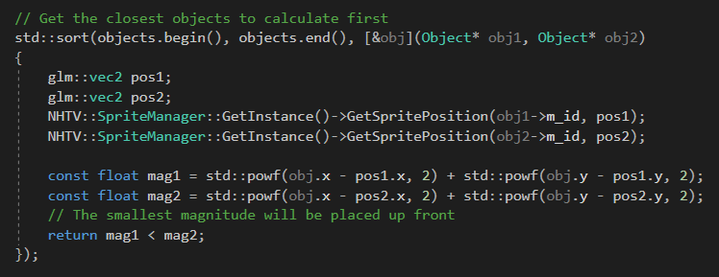

I use the sort algorithm for this. We only have to pass a predicate to it. The lambda should compile into a function object. The reason why we need a function object is we need the player's position also. Finally, we check which magnitude is the smallest, the smallest magnitude gets called first. That solves our snapping problem and the collision runs smoothly like this.

The way a collision is detected and resolved goes as follows.

------

Pos1 = lower left position of obj1

Pos2 = lower left position of obj2

If Pos1 intersects Pos2 (AABB collision)

Call both onCollide functions

X = pos2.x - pos1.x

Y = pos2.y - pos1.y

If abs(x) > abs(y)

Snap x to obj2 side

Else if abs(y) > abs(x)

Snap y to obj2 side

Else // this can happen if the player walks inside of a corner

Position = oldPosition

------

That’s all there is to it. This results in this behavior. I like this solution because it’s very simple but it still works. My old physics engine became a real mess of code. After a while I couldn’t even explain my old code, it just worked. But I can fully understand this function of the physics engine now. I can explain why and what every line does. 

The only thing that has to be fixed is that the player gets moved around by monsters.

### 20:45-22:00 Stopping the player from being pushed around by monsters

The player is being pushed around by monsters, you can see that at the end of the previous gif. The reason why this happens is that the monsters only check collisions with the cell they want to move to. If the monster would overwrite a position on the next frame, the movement gets canceled. I did this because the movement of monsters is cell based in Gauntlet. Because of this though, monsters will move towards a cell until it gets onto that cell. This results in the player being pushed aside because the monster is temporarily inside of the player.

To fix this, we must calculate the direction that the monster is going towards and check if that cell is occupied.

Unfortunately, I can’t think up a solution for this. Imagine if we take the direction the monster wants to move towards. We get that direction, change it to a unit vector and multiply it by the tile size to get the cell that the monster wants to get on. We can check that cell and if there already is an object onto that cell, we just stop moving. The problem here is that if the monster is already inside the cell but not yet at the center, it would check for the next cell. If this cell would contain a wall, the monster would be forever stuck.

Of course, I could just pass a target cell into the function, but only monsters would need that.

The way I see it is by having monsters also have an AABB collision, that seems like the easiest solution, it actually only requires one flag to change.

Unfortunately, it wasn’t that simple. My entities are 28x28 in size. This means that with AABB, two objects could take 1 cell at the same time. This, of course, results into on object overwriting the other one. It may have been easier for me if I kept the entities inside a vector and decide their position based on the map, but it is a bit too late to swap the system back around now. The quickest but kinda dirty solution would be to add a target cell parameter to the requestMove function.

This also didn’t work.

The monsters will stop moving is the tile they are targeting is occupied, but once the object is on the next cell, the monsters will start to move again. To keep it simple, I have to use AABB to fix this.

Thus, I added a flag that specifies whether an object wants to snap or stop moving when a collision happens.



I’m getting real close to a solution, but now my monsters walk into each other. I’m not sure why this happens. Because it isn’t supposed to in my code. I will research it further tomorrow.

# 

# Thursday

### 7:15-8:30 9:30-10:00 Work on reflection

Wrote a lot in the challenges section.

10:15-11:30 Lecture maths

Read about weighted form and implicit line formula

### 11:30-12:00 Asking learning log feedback

Explain more abstract, more in concepts and less exact, less about the project but more about the experience.

### 12:30-14:15 Finish the PDP

### 14:30-16:00 Implement pop up system

### 

# Friday

### 10:00-11:00 Fix bug where the game would crash if the player died

### 11:00-11:45 Write week 6 and 7 ILOs

### 11:45-12:00 Add breakable walls and added food

### 12:15-12:30 Spawners can be broken and the game restarts at the end